Virtual Study Network using Cloud Computing

# Jyotsna More, Nishant Bhatte, Vivek Prajapati and Shreekunj Varia

# Department of Information Technology

Xavier Institute of Engineering Mumbai

# Mahim Causeway, Mahim (West), Raheja Hospital Marg, Mumbai, Maharashtra 400016, India

jyotsna.m@xavier.ac.in, nishant.bhatte30@gmail.com, prajapativivek415@gmail.com, shreekunjvariya@gmail.com

**Abstract — Today in the field of development, research, education, Users need an appropriate hardware specification to perform their task. If the user studies or works from home, they need to have a well-configured PC respective of their task which they have to perform and an ample amount of data. The experimentation, testing, studying and research work becomes difficult if the user is having a low configuration PC, due to which they have to depend on their organization’s PC. Users do not want to experience the complexity in performing experiments at work or home.**

**To resolve these issues, the proposed system will provide a platform where a user can get all the necessary resources, such as application files and operating system instances making them available in the cloud. To access it, users only need a laptop or tablet with minimum configurations and a browser installed in it. The user has to log into the account and select the required resources from the system and the user can perform their task using the different operating system instances from the proposed system. It will also provide security to uploaded documents on cloud which can be access anywhere anytime. The platform can be used for anything like development, testing, demo, production and is accessible from anywhere. As it only requires a device and a stable internet connection, it doesn't need to load anything in the local machine.**

***Keywords* — Virtualization, E-Learning, Cloud Computing, Online Virtual Lab, Virtual OS, AWS, VSCode, Virtual Study Network.**

1. INTRODUCTION
2. *Background:*

If all students are required to study at home during lockdown times, and not all students have computers with excellent specifications, it will be difficult for students to conduct experiments or study. This is especially true for engineering students, who are primarily required to study at home during lockdown times. Because university students rely on computers provided by the university, there are plenty of experiments and activities to be undertaken, and there are circumstances when some students have a personal computer with sufficient or adequate specifications while others do not. Such a student is finding it challenging to perform practical or practice at home. As previously stated, some students lack the necessary materials to undertake experiments. In colleges, high-end gear is also essential for doing practical.

1. *Problem Definition:*

In today's world of development, research, and teaching, users require well-configured machines to do their difficult tasks. Virtual desktops are now accessible using HTML 5 browsers, which are widely available on cellphones, desktops, and tablets. The ability to handle virtual desktop access is integrated into these, so no further extensions or plug-ins are necessary.

The proposed VIRTUAL STUDY NETWORK system will provide a platform for users to obtain a virtual machine from a cloud provider such as aws or google, as well as necessary resources such as application files and virtual operating system images, allowing them to perform all tasks. If the user wishes to study or work, they will require a machine with appropriate specifications and internet access. As a result, the user will receive a virtual operating system image, as well as various apps, software, and other items required for their task. All they have to do now is select the operating systems and start to work. The HTML5, CSS3, and JavaScript/php programming languages will be used to develop the Platform. A user simply needs a laptop, tablet, or smartphone with the bare minimum of specs and a browser loaded to access this platform. The user only needs to sign in to the system to gain access to the resources, after which they can perform their work using the different virtual operating system types. It will also include capabilities such as secure cloud document storage and an online text editor. It will be used for development, testing, and production, and it will be accessible from anywhere. It doesn't require any software to be installed on the local computer; all it requires is a device and a reliable internet connection.

1. *Objective:*

Main Goal of this project is to provide a sufficient resource to users who does not have required resources to perform their task. By implementing this project, it will minimize the requirements of the hardware which will eventually minimize the cost of hardware required. Users can perform their task from different types of devices like tablet, any other device which has an interface.

1. LITERATURE SURVEY

Cloud computing has many benefits while also having certain drawbacks, both of which stem from the fact that all data and applications are stored on the Internet. Because data and applications stored in the cloud may be accessed in real time and online. It can be used in a variety of everyday activities, including education. Cloud computing is a concept for providing simple, on-demand network access to a shared pool of resources.[2]

Major Cloud Computing Service-Providers:

There are several cloud-computing service providers available in industry. Few leading companies are listed below as per Gartner’s Magic Quadrant 4:-

1. Amazon Web Services – Launched in 2006
2. Microsoft Azure - Launched in 2010
3. Google Cloud Platform - Launched in 2008
4. Alibaba Cloud - Launched in 2009
5. Oracle Cloud- Launched in 2012
6. IBM Cloud- Launched in 2011 [3]

Identifying a cloud type or service is a one-of-a-kind decision. No two clouds (even if they're of the same type) are alike, and no two cloud services are utilized to solve the same problem. However, understanding the common factors will help you better understand how the limitations of each cloud computing model and cloud service may affect your organization. [8]

TABLE 1. COMPARISON BETWEEN AWS & GCP

|  |  |  |
| --- | --- | --- |
| **Service** | **Amazon Web Service** | **Google Cloud Platform** |
| Compute Service | EC2 | Compute Engine |
| Kubernetes Management | EKS | Kubernetes Engine |
| Auto Scale Instances | Auto Scaling | Instance Group |
| Object Storage | S3 | Google Cloud Storage |
| Virtual Network | VPC | Subnet |
| Load Balancing Configuration | Elastic Load Balancing | Cloud Load Balancing |

The comparison between Amazon Web Services (AWS) and Google Cloud (Google Cloud) in above TABLE 1 aids in identifying the system's requirements to choose the cloud service according to the need of system.

Pranay Dutta et al. [3] Suggested that despite AWS has the largest share of the cloud service industry, it would be unfair to state that it delivers the best solutions. If you're seeking for simple business solutions or foolproof security, MS Azure and GCP have a variety of features. The notion is that when it comes to Cloud Service Providers, there is no universal best, it all comes down to what best meets your needs.

Computer users are increasingly challenged with software incompatibility as apps, operating systems, and the Internet evolve. Because they do not support new hardware or operating systems, older apps that are crucial to users frequently do not work on newer computer systems. Today's programmers and application developers primarily use laptop computers since they must always have access to all necessary tools and programmes. They use virtualization on their laptop computers as they need to run and test apps in various software environments without having to reinstall all of their existing software. Furthermore, when they visit outside of their primary employer, they do not need to have more than one laptop; instead, they have multiple virtual machines installed on a single laptop. They can also segregate their personal and business software environments by adopting virtualization. [5]

According to Julian Bermudez-Ortega et al. [4] Remote web-based laboratories are technical platforms that enable remote users to operate and observe industrial, research, or educational lab equipment via the internet. Their development for educational purposes has a number of advantages. On the one hand, they allow students to 1) conduct more experiments at any time and from any location than they could in traditional hands-on laboratories; and 2) interact with real equipment and examine their genuine noisy and rich data. They can allow safe access to expensive or risky equipment, as well as increase its use and reduce the chance of spoilage. They are also useful as educational aids for Control Engineering because of these properties.

Web browsers are now practically omnipresent; essentially every computing device, from PCs to mobile phones, has one built in. Browsers are likewise becoming faster and faster. They now include incredibly efficient JavaScript compilers as well as Web Assembly support (an assembly-like language that runs with near-native performance). Modern browsers can now deliver cross-platform and compute-intensive applications because of these advantages [6]. As cloud computing is a very popular and widespread technology nowadays that can be utilised to solve many day-to-day problems, Browser Virtual Machine is a new technique to run unmodified and complete operating systems and programmes inside browsers. Existing non-computing-intensive programmes can be executed natively in browsers [6].

Vinod Nadar et al. [7] System is a software application for storing and accessing data online and users do not need to install the programme on their device because it can be accessed using any Web browser on their cell phones or computers. Their technology also employs a variety of encryption techniques to give customers with adequate security through a two-factor authentication process. We've proposed using QR code-based OTPs to create a secure and reliable authentication mechanism for accessing documents on mobile devices. The system is extremely user-friendly because it does not require any technical expertise on the part of the user.

1. TOOLS AND TECHNOLOGIES
2. **AWS:** Amazon EC2 (Elastic Compute Cloud) is considered to be a web service that offers compute capacity to the cloud which could be resized. Amazon Simple Storage Services (Amazon S3) is one of the divisions that is used to access a large amount of data from anywhere at any time.[1]
3. **HTML/CSS:** HTML (Hypertext Markup Language) and CSS (Cascading Style Sheets) are two of the core technologies for building Web pages. HTML provides the structure of the page, CSS the (visual and aural) layout, for a variety of devices. Along with graphics and scripting, HTML and CSS are the basis of building Web pages and Web Applications
4. **JavaScript:** JavaScript is an interpreted, light-weighted programming language. It is designed for creating network-centric applications. It is complimentary to and integrated with Java. JavaScript is very easy to implement because it is integrated with HTML. It is open and cross-platform.
5. **PHP:** The PHP Hypertext Pre-processor (PHP) is a programming language that allows web developers to create dynamic content that interacts with databases. PHP is basically used for developing web-based software applications.
6. **Xampp:** XAMPP is one of the widely used cross-platform web servers, which helps developers to create and test their programs on a local webserver. It was developed by the Apache Friends, and its native source code can be revised or modified by the audience. It consists of Apache HTTP Server, MariaDB, and interpreter for the different programming languages like PHP and Perl.
7. **MySQL:** MySQL is the most popular Open-Source Relational SQL database management system which is developed by Oracle. MySQL is one of the best RDBMS being used for developing web-based software applications. which is the popular language for accessing and managing the records in the database.
8. METHODOLOGY

The project is making use of Cloud Services but it can be scalable to make use of its own cloud using Open-stack.

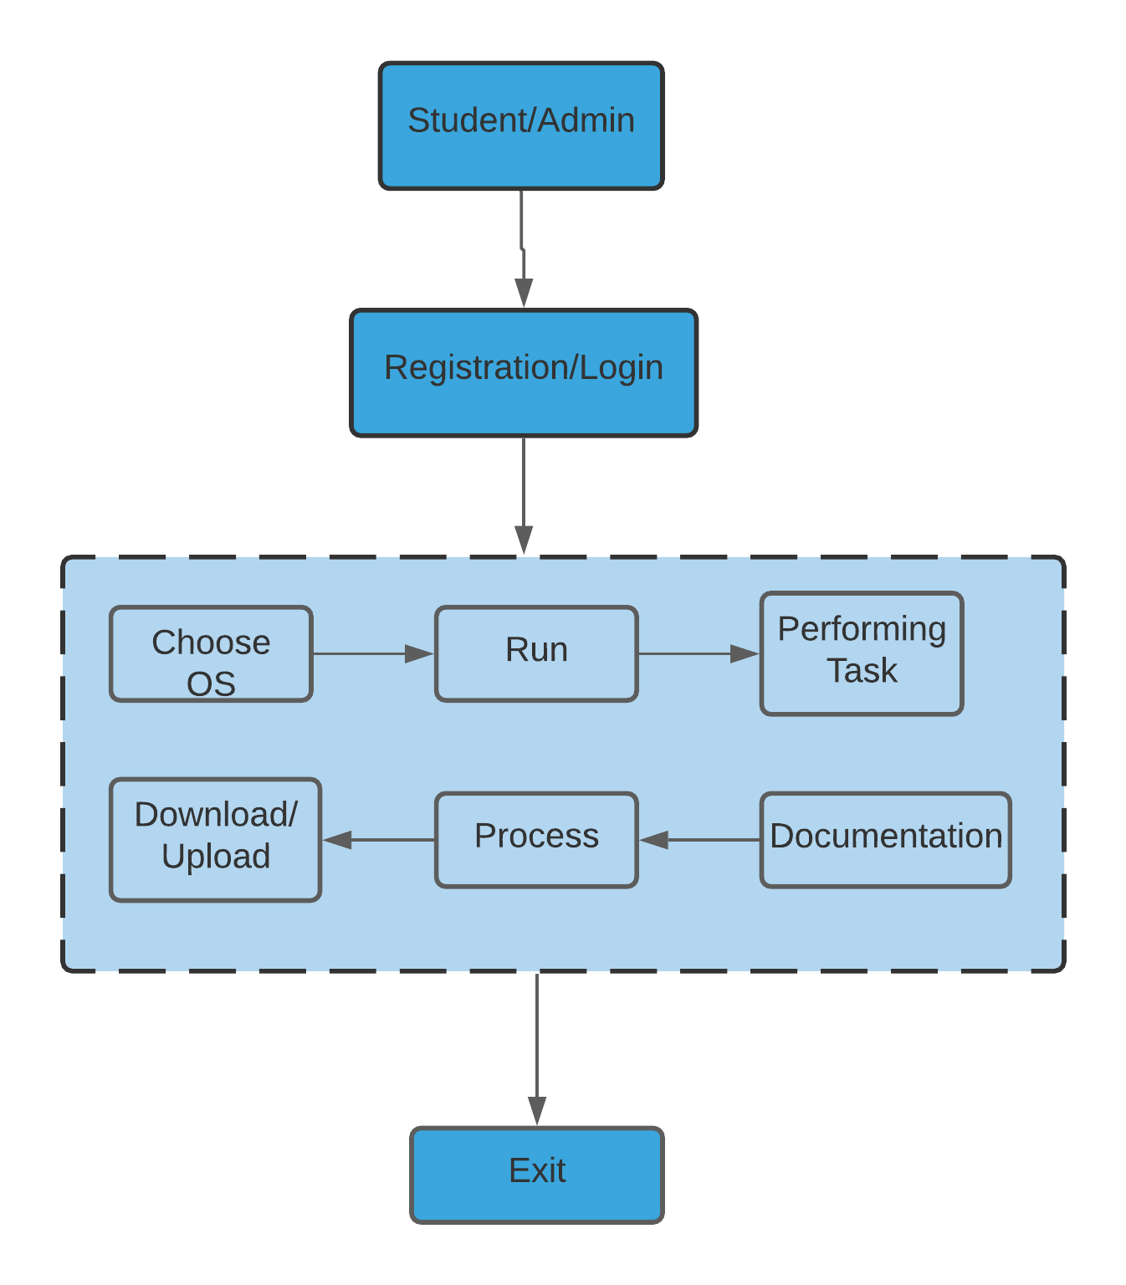

Fig. 1. Block Diagram

The above Fig. 1 is a simplified block diagram of the system, which will include a user interface/website designed with HTML5, CCS3, and JavaScript/PHP. Users must first register, after which they can log into the system to access all of the resources available to them.

AWS/Google cloud services are utilized in these applications. Users can choose from the provided list to run an operating system instance of their choice in order to complete their work.

There will also be a feature that allows users to save files/data to the cloud in a user-friendly and secure manner, and those documents can be downloaded at any time. The system also includes an online editor for document creation. Users can submit documents to the cloud and download them as well.

1. RESULTS

These are the result of this system

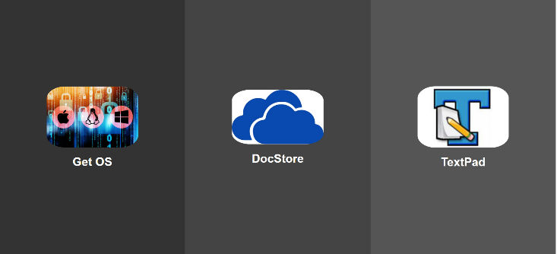

Fig: 2. Interface after Log-in to the System

Above Fig 2 is the website interface which will be visible to the users after they log-in to the system where they can select any module they want.

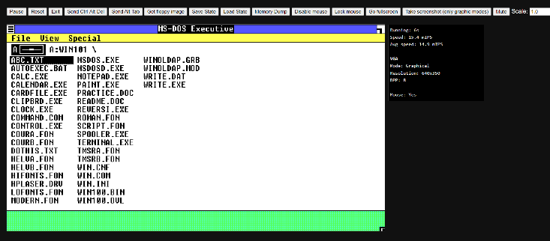

Fig. 3. Loading an Instance/Emulator

The Fig. 3 is an

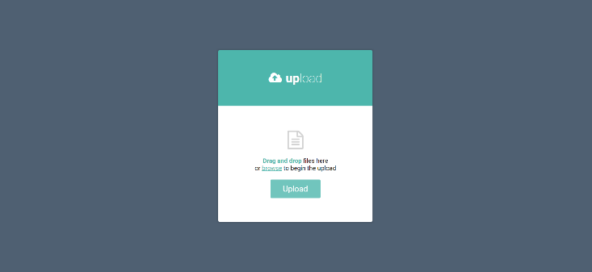

Fig. 4. Upload Document

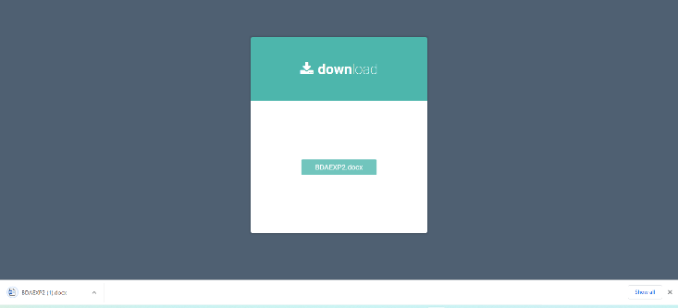

Fig. 5. Download Document

CONCLUSION

The cloud computing is very popular and widespread technology today which can be used to solve many day-to-day problems. VSN is an example of that. The proposed system will provide users with individual OS instances and necessary application file for performing tasks. There are many cloud providers that provides virtual instances, including Amazon Web Service, Google Cloud, Microsoft Azure, IBM Cloud, and many others. So, for the time being this project is being implemented using the cloud provider. But there is also another way to provide virtual instances that is to build our own cloud using open-stack.

The main goal of this system is to run a well-configured virtual operating system on a browser, allowing users to complete tasks without having to download any specific software or application program. This Project can help the student who does not have required specs or high specifications of hardware/computer. There is other application such as storing and accessing data/file online and online text editor. The users won’t have to install the application on their device it can be accessed using any Web browser on their smartphones or a usual desktop.

REFERENCES

[1] A. Bandaru, “Amazon Web Services,” Dec. 2020, p. 5.

[2] Dr. Uday Salunkhe, Sandeep Kelkar, “A Study on The Scope of Cloud Computing in Management Education,” AIMA Journal of Management & Research, May 2016, Volume 10 Issue 2/4, ISSN 0974 – 497

[3] P. Dutta and P. Dutta, “Comparative Study of Cloud Services Offered by Amazon, Microsoft and Google,” International Journal of Trend in Scientific Research and Development, vol. Volume-3, pp. 981–985, Apr. 2019. DOI: 10.31142/ijtsrd23170.

[4] J. Bermudez-Ortega, E. Besada-Portas, J. A. Lopez-Orozco, J. Chacon, and J. M. de la Cruz, “Developing Web Twin Cat Plc-Based Remote-Control Laboratories for Modern Web-Browsers or Mobile Devices,” 2016, pp. 810–815. DOI: 10.1109/CCA.2016.7587918.

[5] G. Martinovic, J. Balen, and S. Rimac, “Impact of The Host Operating Systems on Virtual Machine Performance,” Jun. 2010, pp. 613–618.

[6] E. Wen, J. Warren, and G. Weber, “Browser VM: Running Unmodified Operating Systems and Applications in Browsers,” 2020, pp. 473–480. DOI: 10.1109/ICWS49710.2020.00070.

[7] V. Nadar and V. Yadav, “Skyloader: Document Access Over Cloud,” vol. 7, Feb. 2016.

[8] Red hat, “Cloud Computing.” [Online]. Available: https://www.redhat.com/en/topics/cloud-computing

[9] “V86: x86 virtualization in JavaScript, running in your browser and NodeJS.” [Online]. Available: https://github.com/copy/v86

[10] F. Bellard, “Jslinux-javascript pc emulator running Linux,” *URL: https://bellard.org/jslinux/tech.html*, 2013.

[11] “Jor1k: Online or1k emulator running Linux.” [Online]. Available: https://github.com/s-macke/jor1k